**Software Requirements Specifications And Design Document**

On

**Sessional Management And Event Tracking System**



**Submitted By Under the Supervision of**

Name: Mohd Abbas **Dr. Md. Ashraf Siddiqui**

Enrollment No-: GK 8284

Faculty no-: 24CAMSA114

Course: MCA ( III3RD SEMESTER)

**Department of Computer Science Aligarh Muslim University**

**Table of Contents:**

**Chapter 1: Introduction  
1.1 Literature Survey ............................................................................................................. 3  
1.2 Present State of the Art and Its Shortcomings ...............................................................4  
1.3 Realization of the Problem ...............................................................................................4  
1.4 Introduction of the Problem / Work to Be Taken Up ....................................................5  
1.5 Broad Outline of the Work ..............................................................................................5**

**Chapter 2: Problem Formulation  
2.1 Problem Definition ............................................................................................................8  
2.2 Various Aspects of the Problem ........................................................................................8  
2.3 Present System: Critical View ..........................................................................................9  
2.4 Scientific Novelty and Need of the Work ........................................................................ 9**

**2.5 Proposed System………………………………………………………………………...10**

**Chapter 3: System Analysis and Design  
3.1 System Development Tools .............................................................................................11  
3.2 Information Collection ....................................................................................................12  
3.3 Requirement Specification ..............................................................................................13  
3.4 Analysis and Development of the Actual System ..........................................................14  
3.5 Choice of System for Implementation ...........................................................................15**

**Chapter 4: System Implementation  
4.1 Hardware Requirements .................................................................................................16  
4.2 Software Requirements ...................................................................................................17  
4.3 Input Requirements ........................................................................................................17  
4.4 Operation Manual ...........................................................................................................18**

**Chapter 5: Results and Conclusion  
5.1 Interpretation of Results .................................................................................................20  
5.2 Application Areas and Scope of Work ...........................................................................21  
5.3 Advantages and Special Features of the System ...........................................................22  
5.4 Limitations of the System ...............................................................................................22  
5.5 Future Enhancements .....................................................................................................23**

**References ..............................................................................................................................24**

**Appendices  
Appendix A1: Screenshots ....................................................................................................25  
Appendix A2: Database Tables .............................................................................................27  
Appendix A3: Code Snippets ................................................................................................29  
Appendix A4: Sample Reports .............................................................................................30**

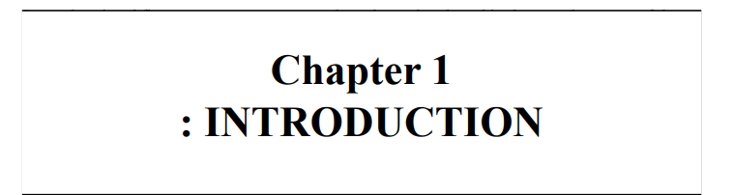

The Sessional Event Management System is a web-based application designed to streamline the planning, organization, and monitoring of sessional examinations within an academic institution. The primary objective of this system is to automate and centralize all processes related to sessional exam events — including scheduling, venue allocation, faculty invigilation assignments, student notifications, and real-time tracking of exam activities.

By replacing manual and paper-based processes, the system ensures improved efficiency, reduced administrative workload, and enhanced accuracy in handling exam-related events. It also facilitates better coordination among departments, enables timely communication, and supports the secure handling of sensitive exam data.

This document outlines the functional and non-functional requirements for the development and implementation of the Sessional Event Management System.

**1.1 Literature Survey**

**a) Previous Related Work**

Managing sessional assessments is a critical part of academic administration in colleges and universities. Traditionally, most institutions rely on manual methods or fragmented systems for tracking sessional marks and exam schedules.

* Manual Record Keeping: Many colleges still use registers or spreadsheets to store sessional marks. This approach is prone to human errors, misplacement of records, and lack of transparency.
* Learning Management Systems (LMS): Tools like Moodle and Google Classroom allow assignment grading but often do not focus specifically on managing sessional exams, their scheduling, and tracking over multiple semesters.
* College ERP Software: Though some institutions use enterprise software solutions, these are often expensive, complex, or not customizable for sessional-specific tracking. Additionally, they may lack features like session-wise performance visualization or role-based access for teachers and students.

**b) Institution/Project Profile**

The Sessional Management and Event Tracking System is developed to streamline the process of recording, managing, and analyzing sessional (internal) examinations within academic institutions. It offers features such as:

* Sessional scheduling
* Student-wise marks entry and editing
* Performance tracking across semesters
* Visualization of sessional results for teachers and students
* Secure, role-based login access

**1.2 Present State of the Art and Its Shortcomings**

Despite the growing adoption of digital tools in education, sessional assessment management often remains inefficient due to:

* Lack of centralized system: Marks are stored in multiple files or departments, leading to confusion and redundancy.
* No real-time access: Students are often unaware of their updated scores until results are manually distributed.
* Poor historical tracking: Teachers and administrators cannot easily track student performance across different sessionals or semesters.
* Data entry issues: Manual entry increases the chances of clerical errors, and there’s no validation mechanism.
* Limited analytics: There's little or no visualization of performance trends, making it hard to identify students needing support.

These limitations highlight the need for a robust, dedicated system to handle all aspects of sessional exams.

**1.3 Realization of the Problem**

Academic institutions are under increasing pressure to maintain transparency, accuracy, and speed in internal assessments. However, it was observed that:

* Faculty members spend significant time on manual mark calculations and data entry.
* Students lack access to a consolidated view of their sessional performance.
* Admins face challenges in compiling data for audits, accreditations, or semester reviews.
* Errors in mark entry or calculation often go unnoticed, affecting student grades unfairly.

This realization led to the need for a dedicated Sessional Management and Event Tracking System that can automate, organize, and simplify internal assessment tracking for all stakeholders.

**1.4 Introduction of the Problem / Work to Be Taken Up**

To overcome these challenges, we propose a Java-based desktop application that digitizes the sessional assessment process.

Core Features:

* Role-based login for Admin, Faculty, and Students
* Sessional exam scheduling (subject-wise, class-wise)
* Marks entry and editing interface for teachers
* Auto-calculation of averages and grade suggestions
* Student portal to view sessional results
* Visual performance dashboards (bar graphs, trends, etc.)
* Database integration for storing and retrieving sessional records

The system is developed using Java Swing for the frontend and AWT/JDBC for backend/database interactions. It is designed to be simple, modular, and scalable.

**1.5 Broad Outline of the Work**

The entire system development is broken into well-defined chapters to cover the conceptualization, design, development, and analysis of the project.

**Chapter 1: Introduction**

This chapter provides an overview of the current challenges faced in managing sessional examinations within academic institutions, such as inefficient scheduling, manual invigilation allocation, and poor communication. It introduces the Sessional Event Management System as a solution, outlining its objectives, significance, and the benefits of automating the sessional exam management process.

**Chapter 2: Problem Formulation**

This section clearly defines the core problem: the lack of an integrated system to manage sessional exam events effectively. It outlines the problem statement, scope of the system, and explains the need for an efficient, automated, and centralized approach to scheduling, coordination, and communication related to sessional exams.

**Chapter 3: System Analysis and Design**

This chapter dives into the technical blueprint of the system. It includes:

* System Architecture: High-level design of the system components and their interactions.
* UML Diagrams: Use case, class, sequence, and activity diagrams to visualize system behavior and structure.
* Database Schema: Tables, relationships, and data flow for managing users, exams, venues, and notifications.
* GUI Planning: Wireframes or mockups for the user interfaces, showing how users will interact with the system.

**Chapter 4: System Implementation**

This section details the practical development of the system, including:

* Technologies Used: Programming languages, frameworks, and tools.
* Code Structure: Organization of modules, classes, and functions.
* User Interfaces: Descriptions and screenshots of developed UI components.
* Module Descriptions: Explanation of key modules such as scheduling, notifications, and real-time tracking.

**Chapter 5: Results and Conclusion**

This chapter presents the results of system testing, user feedback, and evaluation of system performance. It discusses the advantages of the system, any limitations encountered during development, and suggests possible future enhancements such as mobile app integration or AI-based scheduling.

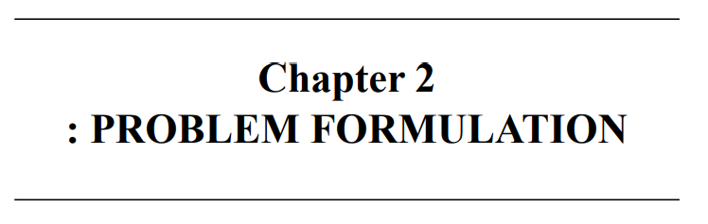

**2.1 PROBLEM DEFINITION**

Efficient coordination of sessional examinations remains a persistent challenge for many academic institutions. Traditional methods—such as manually creating timetables, assigning invigilators via spreadsheets, or notifying students through printed notices—are often time-consuming, error-prone, and difficult to manage at scale.

These methods lack real-time visibility, structured planning, and centralized control, often resulting in exam scheduling conflicts, venue clashes, miscommunication, and administrative overload. Faculty members are burdened with repetitive coordination tasks, while students are left confused about their exam details due to poor communication channels.

To address these challenges, this project proposes a **web-based Sessional Event Management System** designed to centralize and automate all aspects of sessional exam event handling—ranging from scheduling and venue allocation to invigilator assignment and student notifications. The system is intended to reduce manual effort, improve coordination, and enhance overall transparency and efficiency in managing sessional exams.

**2.2 VARIOUS ASPECTS OF THE PROBLEM**

i) **Manual Scheduling and Allocation Conflicts**:  
Most institutions use spreadsheets or offline methods to schedule exams and assign venues or invigilators. This often leads to clashes in dates, double bookings, and lack of oversight, causing last-minute confusion and rescheduling.

ii) **Lack of Centralized Notification System**:  
Students and faculty are typically informed about sessional exam schedules through notice boards or emails, leading to delays in communication or missed updates. There is no real-time notification system to keep users informed instantly.

iii) **No Real-Time Monitoring or Updates**:  
Administrators have no way of tracking ongoing exam sessions or handling unexpected changes (e.g., invigilator absence, room unavailability). This hampers the ability to respond quickly during exam events.

iv) **Limited Data Logging and Analysis**:  
There is minimal or no structured data stored about past exams, invigilator assignments, attendance, or performance trends. This lack of historical data prevents analysis for future planning or performance improvement.

v) **Unintuitive Interfaces for Stakeholders**:  
Existing systems, if any, are not designed with user-friendliness in mind. Faculty, students, and admins often struggle with poorly designed interfaces, leading to errors, inefficiencies, and user dissatisfaction.

**2.3 PRESENT SYSTEM CRITICAL VIEW**

The current system of sessional exam management is largely manual and fragmented. Timetables are created by individual departments, invigilation duties are manually assigned (often leading to overlaps), and venues are booked without a centralized tracker. This decentralized method lacks transparency and coordination.

There is no integration between scheduling, venue booking, invigilation planning, and student notification, which increases the risk of errors and mismanagement. Moreover, administrators do not have access to real-time updates or dashboards to monitor ongoing exam events or plan based on historical data.

Additionally, the present systems lack scalability and cannot be customized easily to accommodate varying academic structures or large numbers of students and faculty. As a result, the existing processes are inefficient, time-consuming, and unsuitable for modern academic environments that require precision, automation, and real-time responsiveness.

**2.4 SCIENTIFIC NOVELTY AND NEED OF THE WORK**

The novelty of the proposed **Sessional Event Management System** lies in its **centralized automation of sessional exam logistics**, combining real-time scheduling, venue allocation, faculty assignment, and notifications in a single unified platform.

Unlike traditional or semi-digital systems, this solution introduces:

* **Real-time updates and tracking** of exam events
* **Role-based access** for administrators, faculty, and students
* **Dynamic scheduling algorithms** to avoid conflicts
* **Automated communication system** for notifications
* **Historical data storage and visualization dashboards** for future planning

By integrating all aspects of sessional management into a responsive and interactive system, the project not only improves current workflows but also enables institutions to scale operations efficiently. The system reduces manual workload, improves accuracy, and enhances the decision-making ability of administrators through data insights.

This work is essential in a digital-first academic environment where timely and transparent management of examination processes is critical to maintaining institutional credibility and student satisfaction.

**2.5 PROPOSED SYSTEM**

The **proposed system** is a web-based **Sessional Event Management System** built using modern technologies such as HTML, CSS, JavaScript (for frontend), and a backend stack (e.g., PHP/Python/Node.js) with a relational database (like MySQL/PostgreSQL).

Key features include:

* **Automated Exam Scheduling**: Admins can define exam periods, and the system auto-generates a clash-free timetable based on available courses and faculty.
* **Venue Allocation System**: Dynamically assigns classrooms based on availability and seating capacity.
* **Invigilator Assignment Module**: Automatically assigns faculty members to sessions while preventing overlaps and ensuring fair distribution.
* **Student Notification System**: Notifies students through email/SMS or in-app alerts about their exam dates, venues, and any changes.
* **Real-Time Dashboard**: Displays active exams, venue usage, and invigilation status for administrators to monitor and manage events.
* **Historical Data Logging**: Maintains detailed records of all sessional events for audits and planning.
* **Role-Based Access**:
  + **Admins**: Manage scheduling, assignments, and dashboards
  + **Faculty**: View invigilation schedules and attendance logs
  + **Students**: View personal exam timetable and venue details

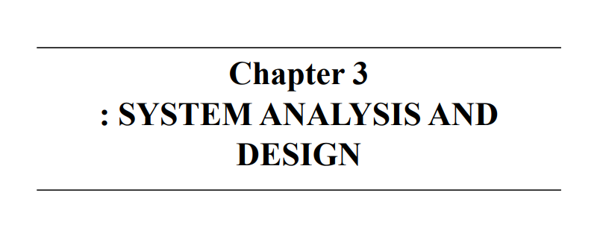

Here's a similar write-up for a **Sessional Management and Event Tracking System** project. This system is designed to manage sessional exams (internal assessments) and track associated academic events like tests, evaluations, and result publishing within an institution.

**3.1 SYSTEM DEVELOPMENT TOOLS**

The development of the **Sessional Management and Event Tracking System** utilized a modern and reliable toolset that ensured effective design, development, and deployment. These tools helped manage code efficiency, database reliability, and user interface intuitiveness.

**i) IntelliJ IDEA / Visual Studio Code**

Used as the primary Integrated Development Environment (IDE) for writing and debugging the backend (Java / Python / Node.js) and frontend (HTML/CSS/JavaScript) code. The IDEs facilitated efficient development, refactoring, and testing processes.

**ii) MySQL / PostgreSQL**

A relational database management system used to store sessional details, student records, marks, event logs, and attendance information. It enables secure storage, indexing, and retrieval of academic data.

**iii) Postman**

Used for testing RESTful APIs during the development process, especially for modules handling sessional record submissions, faculty updates, and result generation workflows.

**iv) Git & GitHub**

Employed for version control and collaborative development. GitHub repositories were used to track code changes, collaborate among developers, and maintain backup of the project source code.

**v) Libraries and Frameworks**

* **Bootstrap / Material UI**: Used in frontend development to create responsive and clean user interfaces.
* **Java Spring Boot / Express.js / Django**: Backend frameworks used to manage server-side logic, data flow, and API creation.
* **JavaScript Libraries**: Libraries like Chart.js were used to display results in a visual format (e.g., bar charts, pie graphs).

**3.2 INFORMATION COLLECTION**

To ensure the system aligned with academic requirements and resolved existing inefficiencies in sessional management, information was gathered through various means.

**i) Review of Existing Academic Systems**

A detailed analysis of traditional methods used in sessional exams and internal event management was conducted. Challenges identified included:

* Manual data entry and error-prone mark recording
* Lack of centralized student performance tracking
* Difficulty in scheduling and communicating exam-related events

This review informed the development of a centralized, digital system to streamline academic operations.

**ii) Faculty and Student Feedback**

Interviews and feedback sessions were conducted with faculty members and students. Common concerns included:

* Inconsistent communication of sessional exam dates
* Delays in marks entry and result display
* Limited transparency on attendance and performance records

**3.3 REQUIREMENT SPECIFICATION**

**3.3.1 Functional Requirements**

The system must deliver the following key functionalities:

**i) Sessional Exam Scheduling**

Admins or faculty should be able to create and manage internal exam schedules for different departments and subjects.

**ii) Marks Entry and Result Management**

Faculty must be able to enter sessional marks securely. The system should automatically generate reports and allow students to view their results.

**iii) Event Tracking Module**

The system should manage academic events related to assessments—such as practicals, viva sessions, re-tests—and update stakeholders accordingly.

**iv) Student and Faculty Portals**

Students can view their sessional results, attendance, and notifications. Faculty can manage subjects, marks, and event records.

**v) Notifications and Alerts**

The system should generate real-time notifications for upcoming sessionals, marks submission deadlines, and event updates.

**3.3.2 Non-Functional Requirements**

**i) Performance and Scalability**

The system should support concurrent logins by multiple students and faculty members, with no performance bottlenecks during peak usage (e.g., result release).

**ii) Security and Access Control**

* Role-based access (Admin, Faculty, Student) should restrict features accordingly.
* User data and academic records must be encrypted.
* Secure login and session handling mechanisms should be implemented.

**iii) Reliability and Availability**

The system must be accessible 24/7 with minimal downtime. Automatic backups and data recovery measures should be in place.

**iv) Usability**

The interface should be intuitive, ensuring that even non-technical users (students or teaching staff) can operate it with minimal guidance.

**3.4 ANALYSIS AND DEVELOPMENT OF ACTUAL SYSTEM**

The **Iterative Waterfall Model** was adopted, ensuring linear development with scope for revisions and user feedback integration.

**3.4.1 Information Collection**

Key academic workflows were studied by observing current exam management and faculty reporting practices. Pain points included delayed mark submissions and disconnected communication among departments, guiding the development of a centralized, automated platform.

**3.4.2 Feasibility Study**

**i) Technical Feasibility**

Developed using:

* Backend: Java Spring Boot / Django
* Frontend: HTML/CSS/JavaScript with Bootstrap
* Database: MySQL  
  These technologies are robust, scalable, and ideal for academic applications.

**ii) Economic Feasibility**

Open-source technologies reduced cost overheads. Minimal hardware requirements allowed implementation even on existing college infrastructure.

**iii) Operational Feasibility**

Simple dashboards, forms, and automated notifications ensured that the system could be used by faculty and students without training.

**3.4.3 Design**

The system design includes:

* **Use Case Diagrams**: Define user interactions (faculty, admin, student)
* **DFD**: Map data flow between components
* **ER Diagram**: Depicts relationships between entities like students, marks, sessionals, and events  
  These diagrams are available in the project appendix for reference.

**3.4.4 Development**

Database tables were created to store students, exams, marks, events, and notifications. Backend APIs were developed for marks submission, report generation, and event updates. The frontend was built to provide interactive dashboards and mark-entry forms.

**3.4.5 Integration and Testing**

System components were integrated and tested for:

* Data consistency
* User role validation
* Accurate report generation
* Real-time notifications  
  Both unit and integration testing were carried out using JUnit (Java) / PyTest (Python).

**3.5 CHOICE OF SYSTEM FOR IMPLEMENTATION**

The For implementing this project in real time, we need several types ofhardware and system software requirements. For this web application, these are the suggested system specifications optimized for compatibility, performance, and efficiency:

1. **Operating System:** Windows 11 or Ubuntu 22.04 (64-bit)
2. **Processor:** Intel Core i5 or AMD Ryzen 5
3. **Memory (RAM):** At least 8 GB
4. **Storage:** 128 GB SSD for faster performance
5. **Internet:** Stable wired or wireless connection
6. **Software Needed:** Java JDK or Python 3.11, MySQL, and Git

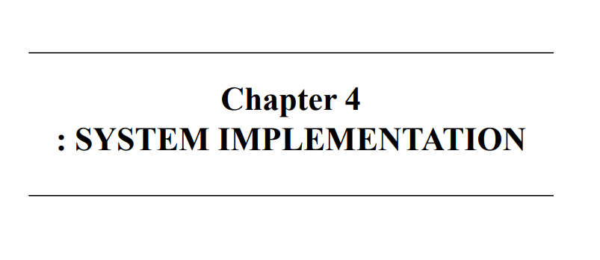

**4.1 HARDWARE REQUIREMENTS**

The Sessional Management and Event Tracking System is designed to operate effectively on common institutional computing infrastructure. The recommended hardware setup is as follows:

**i) CLIENT SIDE**

* **Processor:** Intel Core i5 (8th Gen or above) / AMD Ryzen 5 or better
* **RAM:** Minimum 8 GB
* **Storage:** 128 GB SSD (or higher)
* **Display:** Full HD monitor (1920x1080 resolution)
* **Peripherals:** Standard keyboard and mouse
* **Network:** Stable Ethernet or Wi-Fi connection with at least 50 Mbps bandwidth
* **Supported Devices:** Desktop PCs, Laptops, Tablets
* **Browser:** Latest version of Google Chrome, Firefox, or Edge

**ii) SERVER SIDE**

* **Processor:** Quad-core CPU (Intel Xeon / Ryzen / Core i5 or better)
* **RAM:** Minimum 16 GB
* **Storage:** 128 GB SSD (or higher)
* **Operating System:** Ubuntu Server 22.04+ or Windows Server 2019+
* **Network:** High-speed internet connection (wired preferred for stability)
* **Hosting Options:** Dedicated physical server or cloud platforms such as AWS, Azure, or DigitalOcean

**4.2 SOFTWARE REQUIREMENTS**

The Sessional Management and Event Tracking System is a web-based application developed with a robust technology stack to provide a seamless and user-friendly experience for faculty, students, and administrators.

**i) CLIENT SIDE**

* **Frontend Framework:** HTML5, CSS3, JavaScript with Bootstrap or Material UI for responsive design
* **Dynamic Content Handling:** JavaScript and AJAX for real-time data updates without page reloads
* **Input Validation:** Client-side validation to ensure accurate data entry by users

**ii) SERVER SIDE / BACKEND**

* **Backend Framework:** Java Spring Boot / Django / Express.js for managing business logic, API handling, and authentication
* **Database Management:** MySQL / PostgreSQL to securely store sessional exam details, student records, event data, and results
* **Multithreading / Async Processing:** To handle multiple requests like exam scheduling, marks entry, and event notifications simultaneously
* **Security:** Implementation of authentication (JWT/OAuth), role-based access control, and encrypted data transmission (HTTPS)

**iii) ADDITIONAL TOOLS & UTILITIES**

* **Version Control:** Git & GitHub for code collaboration and version tracking
* **API Testing:** Postman to validate API endpoints during development
* **Logging & Monitoring:** Tools like Log4j or ELK stack to monitor system performance and errors

**4.3 INPUT REQUIREMENTS**

This section outlines the key inputs required from various system users to ensure smooth operation and accurate data handling.

**4.3.1 USER INPUTS (Faculty / Students / Administrators)**

* **Faculty:**
  + Create and manage sessional exam schedules (dates, subjects, duration)
  + Enter student marks and update evaluation results
  + Record attendance and manage event details (practicals, re-tests)
* **Students:**
  + View sessional exam schedules and results
  + Submit requests for re-evaluation or supplementary exams
  + Receive notifications on upcoming exams and results
* **Administrators:**
  + Manage user roles and permissions (faculty, students)
  + Oversee data integrity and event tracking
  + Generate reports on sessional performance and event participation

**4.3.2 DATASET INPUT**

* **Student Information:** Student ID, name, department, enrolled subjects
* **Sessional Exam Details:** Exam dates, subjects, duration, type of assessment
* **Marks and Results:** Scores for each student, grade calculations
* **Event Logs:** Academic events related to sessionals, such as evaluation deadlines, announcements
* **Notifications:** Automated alerts for exam schedules, result publication, and updates

**4.4 OPERATION MANUAL**

The Sessional Management and Event Tracking System offers a streamlined platform for academic institutions to handle internal assessments and track related events efficiently. The system is web-based, accessible via modern browsers, and designed for ease of use by all stakeholders.

**For Faculty:**

* **Scheduling Exams:** Faculty can log in and create sessional exam timetables for their subjects.
* **Marks Entry:** Faculty enter student scores securely and update results as required.
* **Event Updates:** Manage practical exams, make announcements, and communicate deadlines.

**For Students:**

* **Viewing Schedules:** Students can view upcoming sessional exam dates and event notifications.
* **Checking Results:** Access their marks and performance reports once published.

**For Administrators:**

* **User Management:** Add or remove faculty and student accounts, assign roles and permissions.
* **Data Monitoring:** Track all sessional events, verify data accuracy, and generate institutional reports.
* **System Maintenance:** Ensure system uptime, perform backups, and monitor security.

The system is designed for smooth navigation, quick data entry, and timely communication. It reduces manual errors, saves administrative time, and improves transparency in sessional exam management.

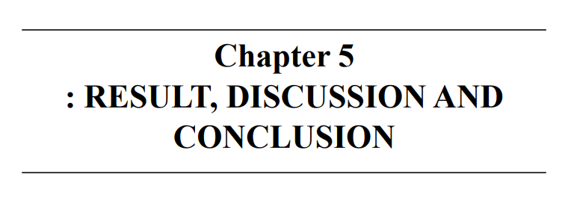

**5.1 INTERPRETATION OF RESULTS**

The Sessional Management and Event Tracking System effectively achieves its core objectives by providing a streamlined, user-friendly platform to manage academic sessionals and related events. Through rigorous testing and simulated scenarios, the system demonstrated its capability to handle multiple processes such as sessional scheduling, event creation, attendance tracking, and result recording. It ensures smooth coordination between students, faculty, and administrators, reducing administrative workload and minimizing scheduling conflicts.

The system also proved efficient in managing event details, including sessional exam dates, time slots, and venues, enabling timely notifications and updates for all stakeholders. Its modular architecture allows flexibility to adapt to different academic calendars and institutional requirements. The user interface was found to be intuitive, enabling faculty to easily create and manage sessionals while students can view schedules and results effortlessly.

Overall, the system satisfies both functional and non-functional requirements by ensuring reliability, scalability, and ease of use. It improves academic sessional management efficiency, enhances communication, and contributes to transparent and organized event tracking.

**5.2 APPLICATION AREAS AND SCOPE OF WORK**

**5.2.1 APPLICATION AREAS**

The Sessional Management and Event Tracking System has broad applications within educational institutions such as schools, colleges, and universities. It serves as a centralized platform for managing sessional exams, practical assessments, and academic events, benefiting various stakeholders:

* **Academic Administrators** can automate sessional scheduling and event notifications, reducing manual effort and errors.
* **Faculty Members** can efficiently create sessional exams, assign evaluation criteria, and track student performance.
* **Students** gain access to updated sessional schedules, event details, and results in real-time, enhancing transparency.
* The system can also support examination boards and educational departments in maintaining organized records of sessional activities across multiple departments.

By providing an integrated solution for sessional management and event tracking, the system ensures timely execution of academic processes and improves overall institutional efficiency.

**5.2.2 SCOPE OF WORK**

The system is designed to offer a reliable and scalable solution for managing sessional exams and associated events. It automates key academic processes such as scheduling, attendance tracking, and result management, thereby addressing the inefficiencies of traditional manual systems.

Core functionalities include the creation and modification of sessional schedules by faculty or administrators, automatic conflict detection to avoid overlapping exams, and real-time visibility of sessional calendars for students. The system supports secure data storage for sessional records and allows authorized users to generate detailed reports on attendance and performance.

Additionally, the platform features an administrative dashboard to oversee all sessional events, monitor timelines, and send notifications for upcoming exams. Its modular design facilitates future enhancements such as integration with learning management systems, automated grading, and advanced analytics for academic performance trends.

Overall, the Sessional Management and Event Tracking System aims to improve academic operations through automation, accuracy, and enhanced communication among all participants.

**5.3 ADVANTAGES AND SPECIAL FEATURES OF THE SYSTEM**

The developed system offers several advantages that modernize and simplify academic sessional management:

* **Automated Scheduling**: Reduces manual errors and avoids session clashes by automatically managing sessional and event timelines.
* **Real-Time Updates**: Students and faculty receive instant notifications about schedule changes, exam details, and results.
* **Centralized Management**: All sessional data, including attendance and results, is securely stored and accessible through a unified platform.
* **User-Friendly Interface**: Intuitive dashboards for both faculty and students streamline interactions and reduce the learning curve.
* **Scalability and Flexibility**: Modular architecture supports customization to fit diverse institutional policies and future feature additions.
* **Efficient Event Tracking**: Enables monitoring of academic events’ progress and timely interventions if required.

These features collectively enhance the transparency, reliability, and efficiency of managing sessional exams and related academic events.

**5.4 LIMITATIONS**

While the system provides a comprehensive solution for sessional management, certain limitations exist:

* **Internet Dependence**: Requires stable internet connectivity to access schedules and updates; performance may degrade in low-connectivity areas.
* **Limited Offline Functionality**: No provision for offline access or management, which might hinder use in areas with inconsistent network access.
* **Handling Complex Academic Policies**: Some institutions with highly customized academic rules may require additional modifications to the system.
* **Manual Intervention**: Certain exceptions or conflict resolutions may still require human oversight beyond automated processes.
* **Data Security Concerns**: As sensitive student information is stored, ensuring robust cybersecurity measures is critical but may need further enhancements.

**5.5 FUTURE EXTENSIONS**

Several potential improvements could enhance the system’s capabilities and user experience:

* **Multi-language Support**: To cater to diverse student populations by offering interfaces in multiple regional languages.
* **Mobile Application**: A dedicated app to increase accessibility and provide push notifications for instant updates.
* **Integration with Learning Management Systems (LMS)**: Sync sessional schedules and results with platforms like Moodle or Blackboard.
* **Automated Grading and Analytics**: Incorporate tools for automatic evaluation of assessments and provide performance insights.
* **Enhanced Security Features**: Implement two-factor authentication and encryption to protect sensitive academic data.
* **Offline Access and Syncing**: Allow users to download schedules and results for offline viewing with synchronization once online.
* **Event Reminders via SMS/Email**: Expand notification options for timely reminders through multiple communication channels.

These enhancements will further improve system accessibility, robustness, and adaptability to evolving academic needs.

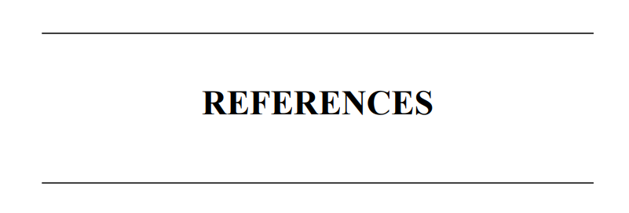

**REFERENCES**

[1] W3Schools. Java Swing and AWT Tutorials for GUI Development [online]. Available at:  
<https://www.w3schools.com/java/java_swing.asp> [Accessed 21 September 2025].

[2] GitHub. Sessional Management System Sample Projects [online]. Available at:  
<https://github.com/topics/sessional-management> [Accessed 20 September 2025].

[3] GeeksforGeeks. Java Programming for Desktop and Web Applications [online]. Available at:  
<https://www.geeksforgeeks.org/java/> [Accessed 19 September 2025].

[4] Oracle. JDBC Documentation for Database Connectivity in Java [online]. Available at:  
<https://docs.oracle.com/javase/8/docs/technotes/guides/jdbc/> [Accessed 21 September 2025].



**Appendix A1**

DATA FLOW DIAGRAM

A Data Flow Diagram (DFD) is a structured analysis diagram that shows how data moves through a system. It represents processes, data stores, inputs, and outputs, helping to understand the flow of information.For this project:

* At the Context Level (Level 0 DFD), the system is represented as a single process interacting with external entities (Admin, Faculty, Student).
* At the Level 1 DFD, the system is broken down into sub-processes like Exam Scheduling, Marks Management, Student Management, Notifications, and Event Tracking.

The DFD helps visualize how data is entered, processed, stored, and retrieved in the system, making it easier to design the backend database and ensure smooth data handling.

**Sessional Management and Event Tracking System :**

**Context Level DFD**

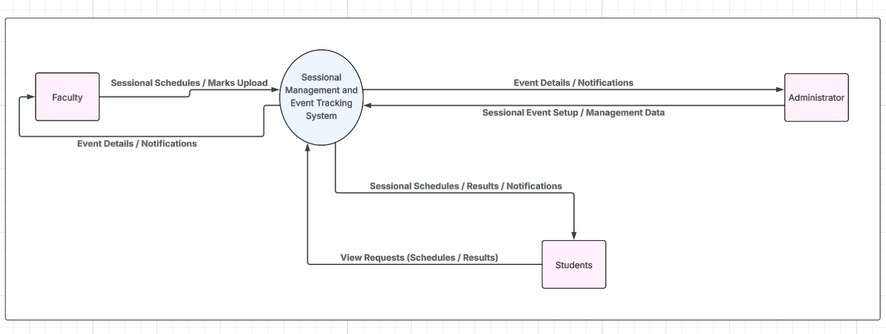

**Level-1 DFD**

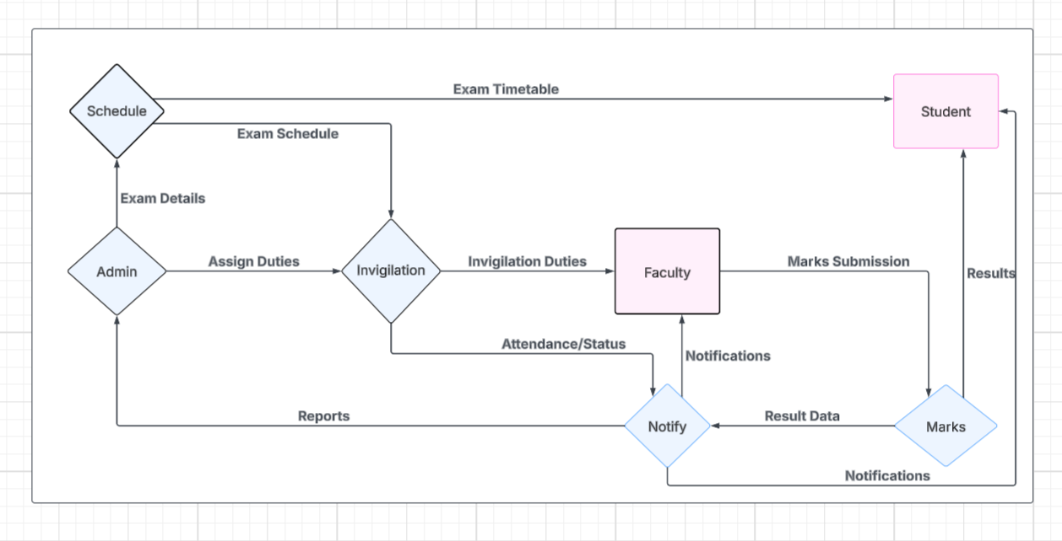

**Appendix A2**

USECASE DIAGRAM

A Use Case Diagram is a UML diagram that represents the functional requirements of the system by showing actors (users or external systems) and their interactions with use cases (system functions). It focuses on *what the system should do* rather than *how it does it*.

For the Sessional Management and Event Tracking System, the main actors are:

* Admin – manages exams, schedules, notifications, and users.
* Faculty – enters marks, views schedules, and manages sessional records.
* Student – views schedules, results, and receives notifications.

The use case diagram provides a high-level functional overview of the system, ensuring that all user requirements are captured before moving into detailed design.

**Symbols and Notations**

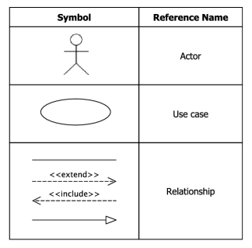

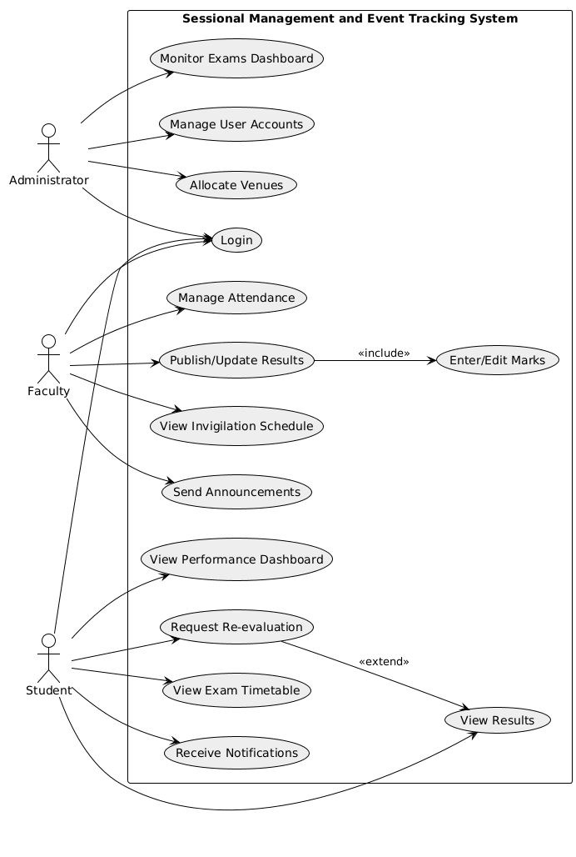

**Appendix A3**

CLASS DIAGRAM

A Class Diagram is a structural UML diagram that represents the static design of the system. It shows the classes (entities) in the system, their attributes, methods (operations), and the relationships among them.In the Sessional Management and Event Tracking System, the class diagram highlights the main components like Admin, Faculty, Student, Exam, Event, Result, and Notification. It illustrates how:

* Admin manages exams, events, and notifications.
* Faculty enters and updates marks.
* Students view schedules, notifications, and results.
* Supporting entities like Exam, Event, Result, and Notification connect the users with system operations.

This diagram provides a clear overview of the system architecture and the roles of different modules, making it easier to design and implement the database and code structure.

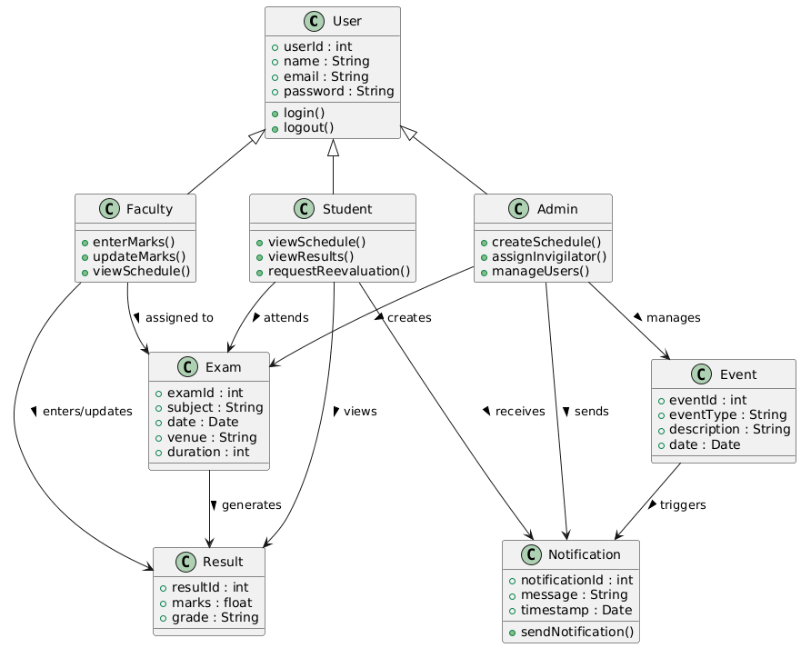

**Appendix A4**

SEQUENCE DIAGRAM

A Sequence Diagram is a behavioural UML diagram that shows the interaction between objects/actors over time. It represents the flow of messages exchanged between different system components in a specific use case scenario.

In this project, the sequence diagram demonstrates the workflow of Faculty entering marks and Students viewing results. It shows step-by-step interactions such as:

1. Faculty logs in, enters marks, and the system stores them in the database.
2. Students log in and request to view their results.
3. The system retrieves the marks from the database and displays them.

This helps visualize real-time communication, ensuring that the design covers all required interactions between users and the system

**SEQUENCE DIAGRAM**

